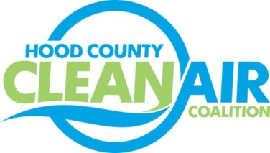
Meeting: Thursday, October 6, 2016
Neely House
304 East Rucker Street, Granbury, Texas 76048
8:30-10:00 a.m.

Agenda

- Call Meeting to Order
- EPA Updates – Randy Pitre
- Regional Updates – Michelle McKenzie
  - FY 2017 Training and Event Schedule
  - White House Seeking Pledge-Style Fleet Electrification and Charging Infrastructure Commitments from Local Governments
  - North Central Texas Energy Forum Scheduled for October 26th, 9:30-3:30, West Irving Library
  - Feedback Requested about Fleet Alternative Fuel Vehicle Obstacles and Procurement Plans Until the End of the Year: https://www.surveymonkey.com/r/FleetsFortheFuture
  - Air Quality Funding Opportunities for Vehicles
- Local Updates – Michelle McKenzie
  - Review of September Meeting Summary
  - Review of Projects
    - Monthly Budget Review for August
    - Status of Projects FY 16/17
  - Reports
    - September Ozone Update
    - Community Appreciation Day
    - Air North Texas Conference Call
    - OA Update
5.) Discussion
6.) Adjourn

